|  |  |  |  |
| --- | --- | --- | --- |
|  | Imagine Communications  25 Dyas Rd, North York, ON M3B 1V7  +1 866-446-2446 www.imaginecommunications.com |  |  |
| TEST status report | | | |
| Product summary | | | |
|  | | | |

|  |  |  |
| --- | --- | --- |
| device under test id | TEST name | test version |
| UNKNOWN_DUT | IOX-SAN-2U-CORE Test |  |

|  |  |  |  |  |  |  |  |  |  |  |  |  |
| --- | --- | --- | --- | --- | --- | --- | --- | --- | --- | --- | --- | --- |
| |  |  |  | | --- | --- | --- | | tester | test date | test duration | |  | 1969-12-31 19:00:00 | 0 | | Test description | | | |  | | |  Status Summary |
|  |
| Test OUTcome |
| ABORTED |

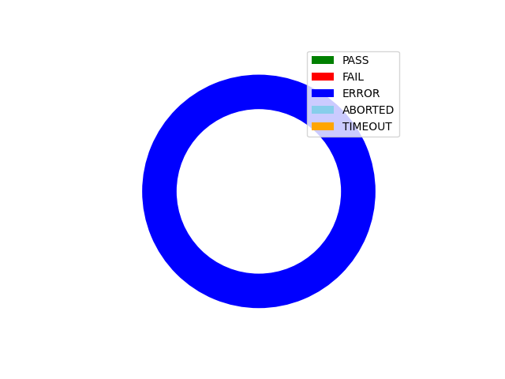

|  |
| --- |
| TEST overview |
|  |

|  |  |  |  |  |  |  |
| --- | --- | --- | --- | --- | --- | --- |
| phase | PHASE name | OUTCOME | test duration | Notes | | |
| **1** | **IOX-SAN-2U-CORE Drive Health** | **ERROR** | **221322** | | **None** | | |

|  |
| --- |
| Test Phase results |
|  |

|  |  |  |  |
| --- | --- | --- | --- |
| phase name | outcome | measurement | Measured VALUE |